Project Design Phase-II
Technology Stack (Architecture & Stack)

Date | 06-11-2022
Team ID | PNT2022TMID04063
Project Name | IOT Based Smart Crop Protection System For Agriculture
Maximum Marks | 4 Marks

Technical Architecture:

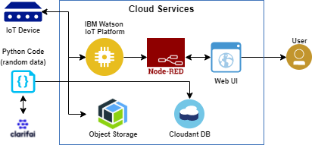

Table-1 : Components & Technologies:

S.No | Component | Description | Technology
1. | User Interface | Interacts with IOT Devices | HTML, CSS, JS
2. | Application Logic-1 | Logic for a process in the application | Python
3. | Application Logic-2 | Logic for a process in the application | Clarify
4. | Application Logic-3 | Logic for a process in the application | IBM Watson Assistant
5. | Database | Data Type, Configurations etc. | MySQL, NoSQL, etc.
6. | Cloud Database | Database Service on Cloud | IBM DB,IBM Cloud etc.
7. | Infrastructure (Server / Cloud) | Application Deployment on Local System / Cloud Local Server Configuration:  Cloud Server Configuration : | Local, Cloud Foundry, Kubernetes, etc.
8. | File Storage | File Storage requirements | IBM block storage or other storage service or local file system
9. | External API-1 | Purpose of external API used in the application | IBM weather API etc.,
10. | IOT Model | Purpose of IOT Model for integerating the sensors with the user interface. | IBM IOT platform.

Table-2: Application Characteristics:

S.No | Characteristics | Description | Technology
1. | Open-Source Frameworks | Open-source frameworks used | Python
2. | Security Implementations | Authentication using encryption | Encryptions
3. | Scalable Architecture | The scalability of architecture (3 – tier, Micro- services) | Web UI Application server-python, clarify database server-IBM cloud  services Technology.
4. | Availability | It is increased by Cloud and database | IBM cloud services

S.No | Characteristics | Description | Technology
5. | Performance | Design consideration for the performance of the application (number of requests per sec, use of Cache, use of CDN’s) etc. | IBM cloud services

References:
https://c4model.com/
https://developer.ibm.com/patterns/online-order-processing-system-during-pandemic/ https://www.ibm.com/cloud/architecture
https://aws.amazon.com/architecture
https://medium.com/the-internal-startup/how-to-draw-useful-technical-architecture-diagrams-2d20c9fda90d

